9.Write a Pandas program to create a Pivot table and find the total sale amount region wise, manager wise, sales man wise.
Aim:
To write a Pandas program to create a Pivot Table and find the total sale amount region-wise, manager-wise, and salesman-wise.
Program:
import pandas as pd

data = pd.read_csv("sales.csv")

pivot = pd.pivot_table(
data,
values="Sale",
index=["Region", "Manager", "Salesman"],
aggfunc="sum"
)

print(pivot)
Output:
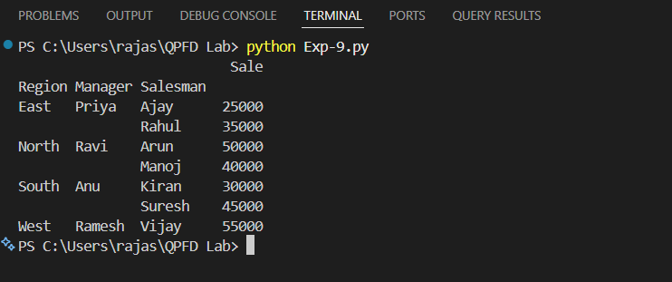

10.Create a dataframe of ten rows, four columns with random values. Write a Pandas
program to highlight the negative numbers red and positive numbers black.
Aim;
To create a DataFrame of 10 rows and 4 columns with random values and highlight negative numbers in red and positive numbers in black.
Program:
import pandas as pd
import numpy as np

data = pd.DataFrame(
np.random.randint(-100, 101, size=(10, 4)),
columns=["A", "B", "C", "D"]
)

def color_value(val):
if val < 0:
return "color:red"
else:
return "color:black"

styled = data.style.map(color_value)

print(data)

styled

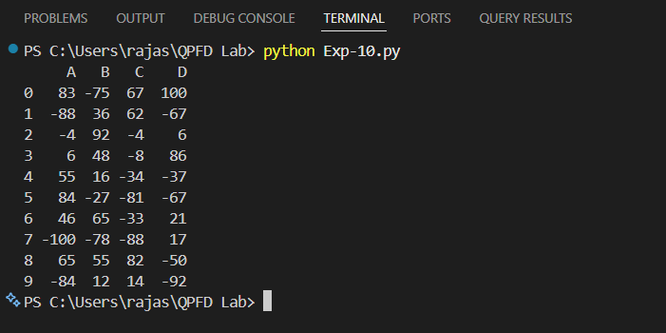
Output:
Result:
The program successfully created a DataFrame with random values and highlighted negative numbers in red and positive numbers in black.

